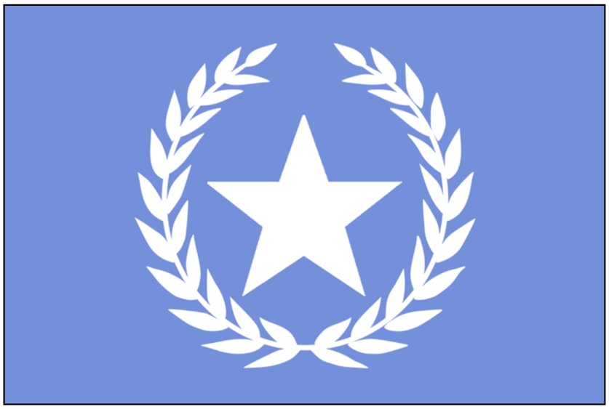


Population: 10000 FAS citizens (estimated)

Starting Crew, Resources and Units:
8 Untrained Crew
4 Security Units
1 Medical Crew
2 Fighter Squadron Units
1 Pilot Crew
2 Water
3 Materials
2 Fuel
2 Food
1 Transport Shuttle

The FAS may not be the indisputable superpower it was centuries ago, but your legacy is still strong. Before 'The Attack', the FAS had an enviable economy and its citizens enjoyed an excellent quality of life. It is only fitting that the vessel representing the FAS in the fleet is a luxury liner – it is representative of what you deserve as one of the oldest and proudest factions.

The Dione is also the largest ship in the fleet (although the Aegis is *technically* more massive). As such, it was tasked with taking on a large amount of civilian refugees when The Attack happened. This population represents the greatest hope for the continuation of mankind, so although you don’t make food and water for yourself, your ship NEEDS the support of the rest of the fleet to keep the human race alive, and the rest of the fleet should be reminded of this, loudly and often.

The people of the FAS take great pride in their vessel being the home of the new Interstellar Council. The President was born a resident of the FAS – though legally the President is bound to not allow this to affect their neutrality, you would do well to remind the President of their roots lest they face a vote of no confidence.

The CPA and SAN are old enemies but you have more in common with them now than you do with the New Nations. Along with you, they formed a strong coalition in the old power structure as a counter to the ascending power of Rosal and Gliese (and the also-ran Proxima, I suppose). Work with them to keep this balance of power intact.

Keep an eye out for the machinations of Rosal. For decades, they've taken every opportunity to undermine your power in the Council – they cannot be trusted with anything. Of the three New Nations, you view them as the only legitimate threat to upending the balance of Old Power, should they go unchecked.

Gliese have an annoying habit of exhibiting a “New Nation” style rebellious spirit, but you tolerate their insolence given their control of important resources. They really ought to know their place, though…

Proxima are uncultured, loudmouthed blowhards and despite their rhetoric, like the other new nations they have no real power. You consider them more of an irritation than an enemy and hardly give them any thought.

Helvetii is an enigma and a recent addition to the Council. They seem to have the “New Nation spark” but are very open minded and consistent with their neutral political approach. They could prove to be a good negotiator and ally.

Reminder - The First Officer must report to the Fleet Map during Wolf attacks to direct the Dione’s fighters.

Objectives

• Ensure that the FAS are respected as the proud and powerful nation it was on Old Earth. Do not let our legacy be disrespected. The greatest artists, statesmen, and scientists in all of human history came out of the FAS, do not forget this.

• The Council's location on your vessel is important to you – oppose any attempt to move the Council to another vessel.

• Keep an eye on Rosal and prevent them exerting any significant influence in the Council. Reduce their influence and strength whenever possible.

